Result of gutprotocol.txt

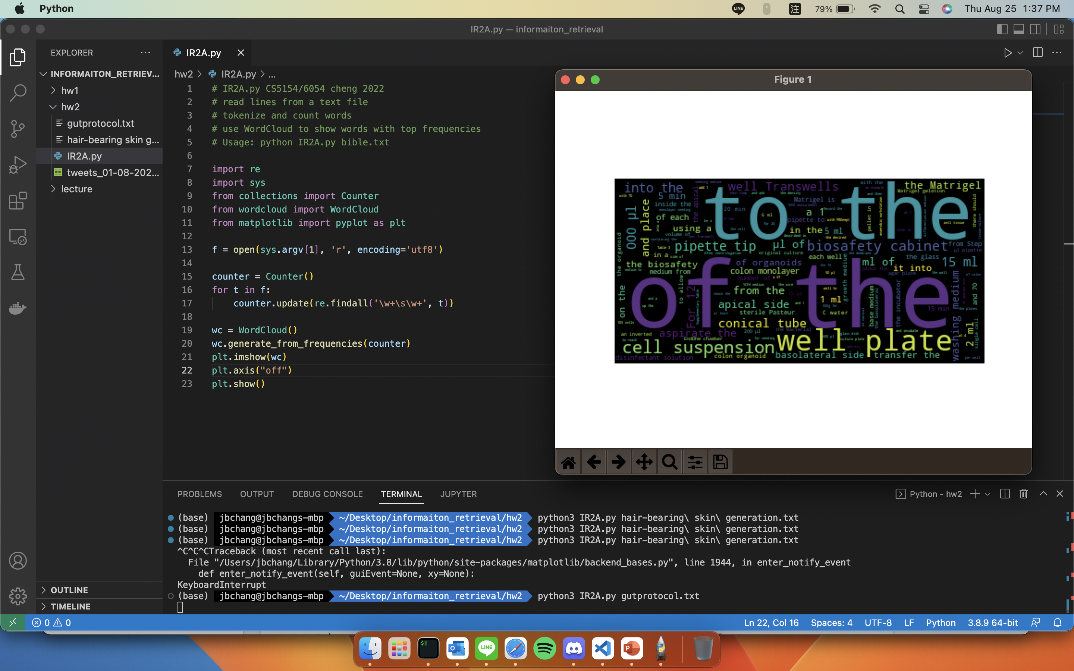

Result of hair-bearing skin generation.txt

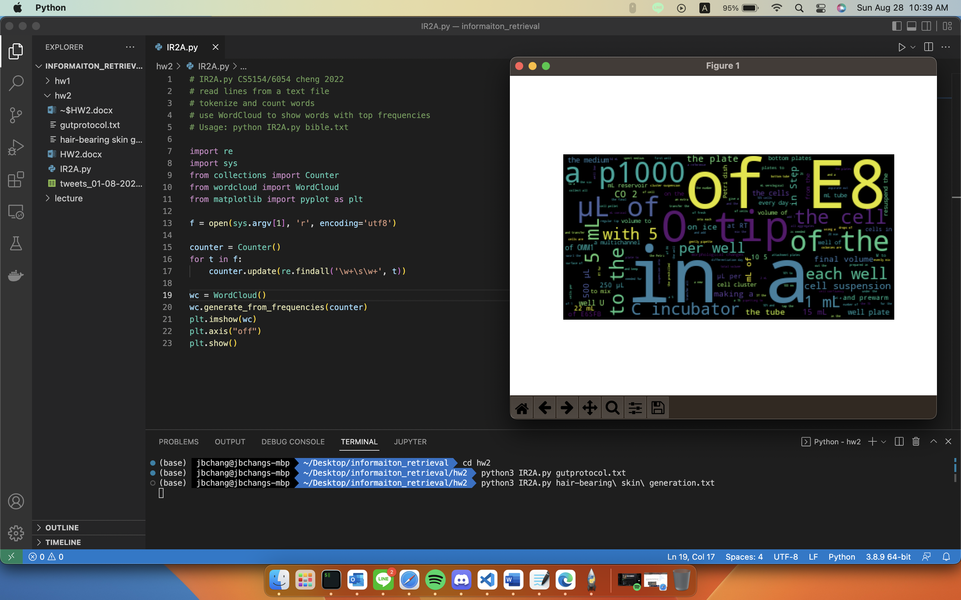

Result of tweets_01-08-2021.csv

